Construction of Circuit

Submitted By: Shumaim Jameel 2025-CE-116

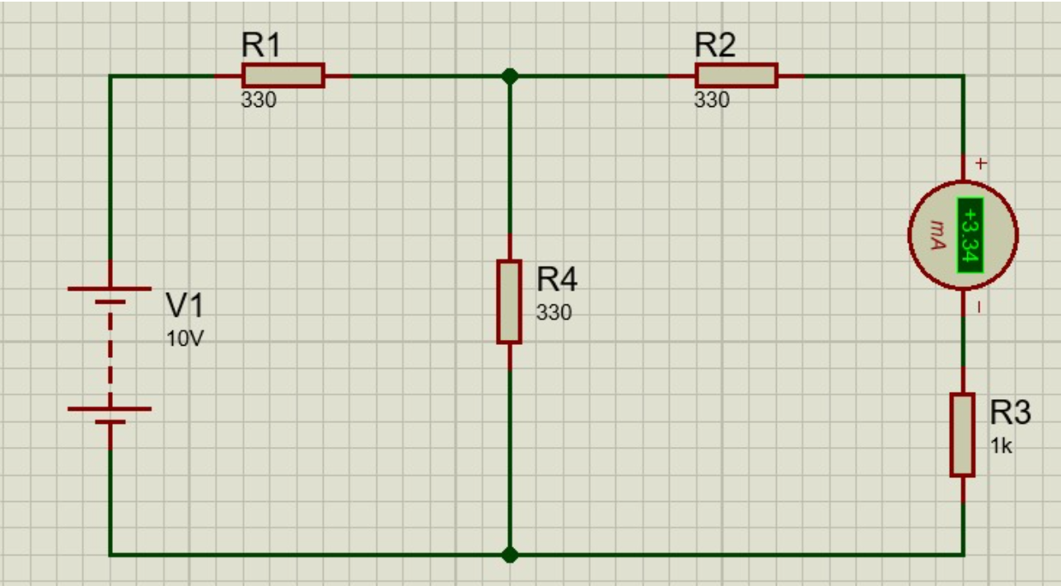
Proteus Circuit

Construction of Circuit
To construct this bridge-like circuit, follow these steps to organize the components according to the provided schematic:
Component List
- DC Power Supply (V1): 10V.
- Resistors:
  - R1, R2, R4: each.
  - R3: ().
- Ammeter: Set to mA (milliampere) range.
- Connecting Wires and Breadboard.
Construction Steps
- Step 1: Power Source Placement
  - Connect the positive terminal of the 10V DC supply to the input node of resistor R1.
  - Connect the negative terminal of the supply to the common ground (bottom rail).
- Step 2: The Input Branch (Mesh 1)
  - Connect the other side of R1 to a central junction point (the top middle node).
  - From this central junction, connect one end of R4 () vertically down to the common ground rail.
- Step 3: The Output Branch (Mesh 2)
  - From the same central junction point (where R1 and R4 meet), connect one end of R2 () horizontally.
  - Connect the other end of R2 to the positive (+) lead of the ammeter.
- Step 4: Completing the Series Path
  - Connect the negative (-) lead of the ammeter to one side of resistor R3 ().
  - Connect the remaining side of R3 back to the common ground rail.
- Step 5: Final Check
  - Ensure all ground connections (V1 negative, R4 bottom, and R3 bottom) are electrically common.
  - Verify the ammeter orientation matches the polarity shown to ensure a positive reading (current flowing from top to bottom).
